Workshop Description

Learn how to make Polvorones - Cuban guava cookies from scratch with chef/Food writer Keshia Sakarah, a recipe taken from her debut cookbook - 'Caribe- a Caribbean cookbook with history' which explores the foodways, ingredients and cultures throughout the region.

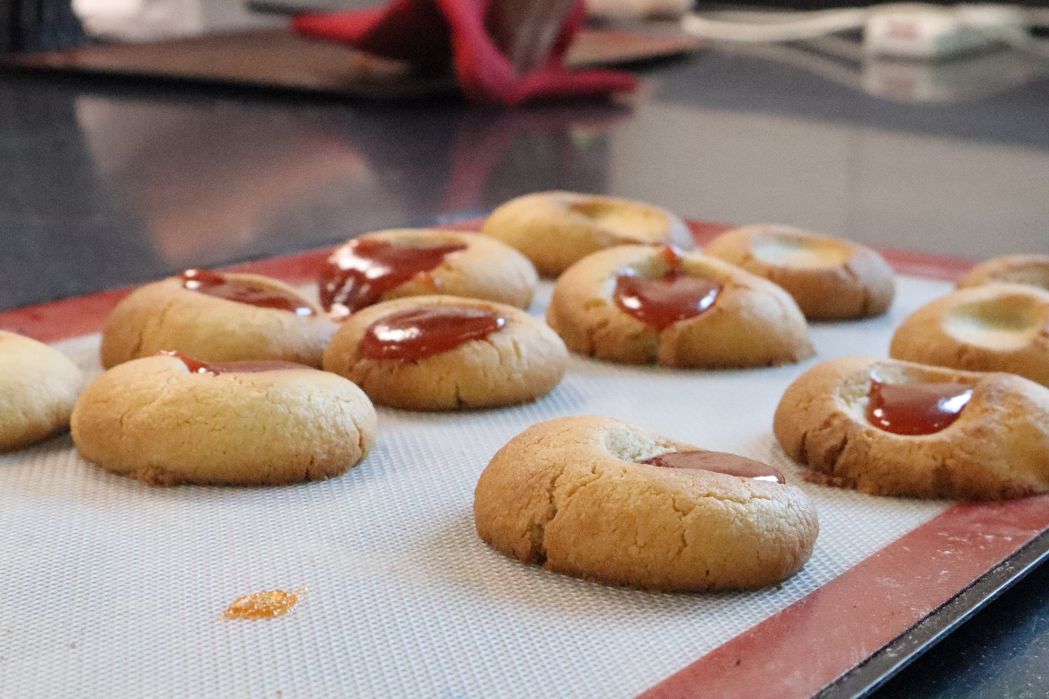

Equipment List
baking trays
baking/greaseproof paper
large bowls
wooden spoons
spatulas
small sieve
large sieve
measuring spoons
knife
spoon

Ingredients List
600 g salted butter, softened
300 g vegetable shortening
540 g golden caster (superfine) sugar
5 egg yolk
1000 g plain (all-purpose) flour
350 g ground almonds
1 ¼ teaspoon sea salt
2 ¼ teaspoon ground cinnamon
guava jam (jelly), to garnish
Icing sugar for dusting

Method
Preheat the oven to 190°C fan (400°F) and line a baking sheet with baking parchment. Put the butter, vegetable shortening and sugar into a large bowl and beat until light and fluffy, then whisk in the egg yolk until well incorporated. Sift in the flour, ground almonds, salt and cinnamon. Fold through until well incorporated, being careful not to over mix – the texture should be grainy. Form spoonfuls of the mixture into 12 balls, then place on the prepared baking sheet.

Press a small dent into the top of the biscuits using your finger, then repeat with the remaining dough. Bake in the oven for 15 minutes, then remove from the oven and place 1–2 teaspoons of the guava jam (if using) into the dents. Return to the oven and bake for a further 5 minutes. If you’re not using guava jam, skip this step. Once baked, remove from the oven and leave to cool on the tray. They will be a little soft to touch and the jam may be hot. Allow to cool before eating.
