Workshop Description

Lalit Kumar, Executive Chef, InterContinental London Park Lane, prepares a vibrant, healthy salad paired with the flavourful, traditional Indian dish – Tandoori Chicken.
The focus will be on preparing a vibrant, healthy salad paired with a flavourful, traditional Indian dish – Tandoori Chicken. Students will learn how to balance nutrition while celebrating the richness of diverse culinary traditions.

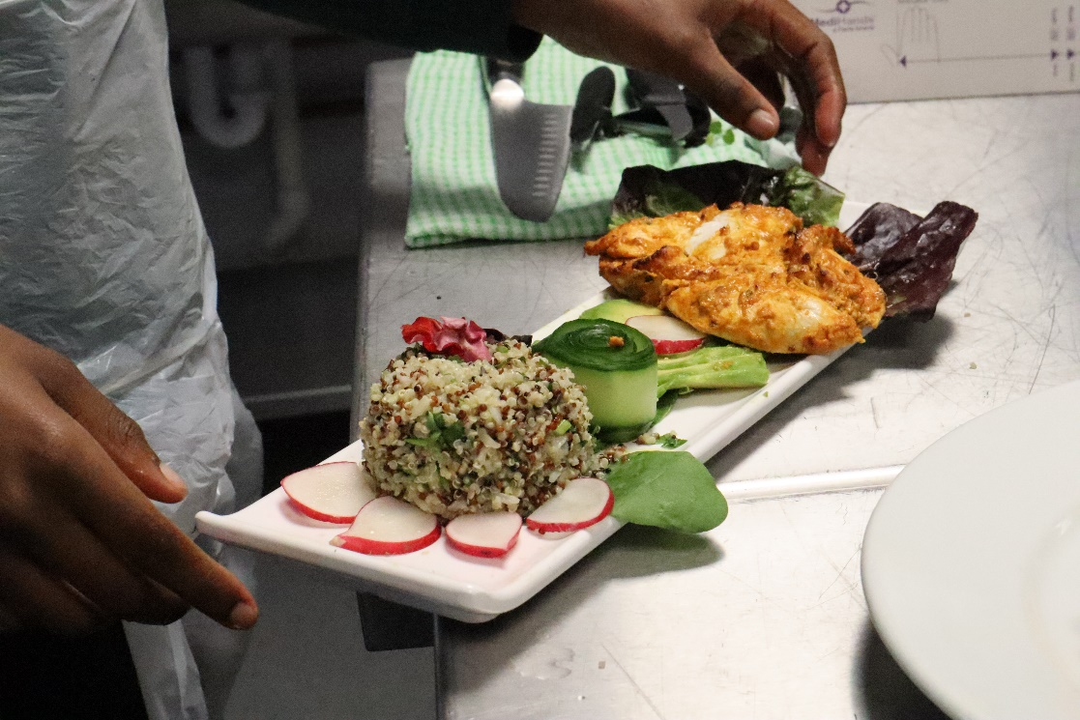
Method
- Prepare the tandoori marinade with spics, ginger garlic paste, oil.
- Apply marinade to chicken and leave it for 20 mins in fridge.
- Boil water to cook brown rice and quinoa.
- Wash & peel carrot and cucumber.
- Clean and prepare lettuce &radish.
- Slice mangoes & avocado.
- Cook chicken at 180 C for 16-18 mins.
- Plate the salad.
- Rest the chicken for 2 minutes and slice to be plated on salad.

Equipment List
Sauce pots
Frying pan
Mixing bowls
Oven
Mandolin
Knives
Salad bowls
Chopping board – red, brown & green.

Ingredients List
Lettuce – Lollo rosso
Fraise
Baby spinach
Heritage tomatoes
Cucumber
Rainbow carrot
Avocado
Radish
Mango
Quinoa
Brown rice
Olive oil
Honey
Mustard
Vinaigrette
Edible flower
Tandoori marination
Chicken breast

