Sticky harissa and miso aubergine, chermoulah, tahini sauce, toasted almonds

Chef Ayesha Kalaji serves harissa and miso aubergine with tahini sauce in a dish that marries North African spices, Middle Eastern cuisine and a touch of Japanese umami.
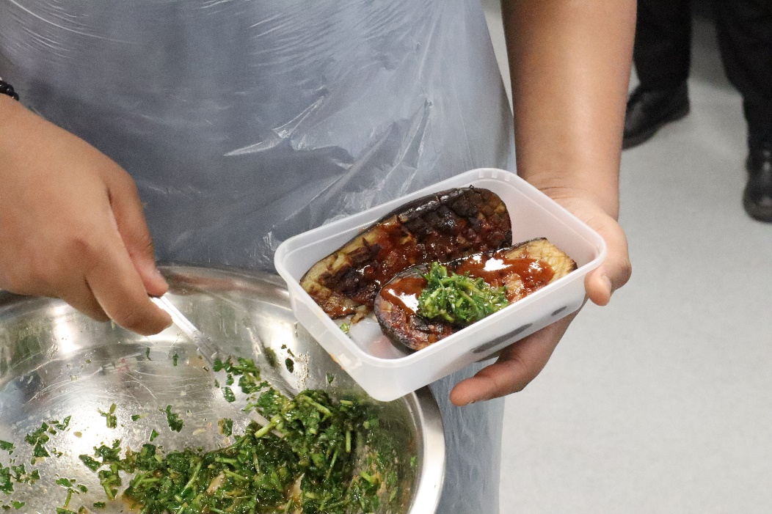

Sticky harissa and miso aubergine
This dish is sticky, sweet and spicy. The marinade can be used for any veg or protein. If you are missing ingredients, you can swap them out. It is all designed to be adaptable and something you can make at home.
Tahini is one of the most common ingredients in Middle Eastern food. Here we make a sauce for the base. Super versatile
Chermoulah is a spicy, herby, tangy north African sauce. Traditionally made with preserved lemons. We are just using lemon juice today though.

Aubergines

Equipment needed:
Chopping board
Chef knife
1 medium bowl
1 small bowl
Colander
Roasting dish
Frying pan

Ingredients:
1 aubergine
3 tbsp rapeseed or any cooking oil.
Sea salt

For the sauce:
1tbsp agave
1tbsp soy sauce
1tbsp rice wine vinegar
1 tbsp harissa
1tsp miso

Method:
Pre heat the oven to 220c. HOT
Take the aubergine and slice in half. Cross hatch the surface on display
Place in a bowl, sprinkle over 1tsp of sea salt over the exposed surface. Leave for 15 minutes. The longer the better! We are trying to draw the moisture out.
Combine all sauce ingredients in a small bowl. You can use a sauce whisk or spoon for this!
When they have sat for fifteen minutes, wash off the excess salt and pat dry.
Add the rapeseed oil to a pan and turn up hot. Fry the aubergine face down in this until nice and evenly golden. This will take about five to seven minutes.
Put the aubergine face up in your roasting tray and pour half the sauce over them.
Put in the oven for 15 minutes
Take out the oven and add the other half of the sauce and put back in the oven for another 10-15 minutes. We want them to be squishy and caramelised.

Tahini sauce

Ingredients
30g tahini
30ml water + some extra
1 lemon

Equipment
Small bowl
Chopping board
Small whisk

Method
Mix the tahini with the water in a bowl.
Cut the lemon in half and squeeze the juice in, being careful not to get any seeds in!
Add some salt to taste and add more water or lemon juice if required.

Chermoulah
25g of coriander, roughly chopped
10g of parsley, leaves picked and roughly chopped
5g of garlic, (about 1 clove)
Juice of one lemon
50ml of olive oil (extra virgin if possible, but pomace will work)
1 pinch of flaky sea salt
1 pinch paprika
1 pinch of cumin
1 pinch of cayenne pepper

This can be done in a blender of by hand!

Blender method:
Microplane or finely grate the garlic into a blender
Add all the herbs, spices and blend until course. Add half the lemon juice.
Add half the oil.
Taste seasoning and add more lemon and more oil as appropriate until desired consistency is reached.

Hand method:
Microplane or crush the garlic with your knife.
Finely chop all the herbs and add to a bowl
Add the lemon juice
Stir in the olive oil
Add salt to taste

Garnish
Small handful of flaked almonds
Cooking oil

Method:
Fry with a little oil in a pan over a medium heat. We want them to be golden brown
Pop them onto a plate with kitchen roll underneath to soak up excess oil
Season with salt

Order of cooking!
1)Cut and salt aubergine
2)Preheat oven to 220
3)Make the marinade
4)Make the tahini sauce
5)Put frying pan on a medium heat
6)Fry the aubergine
7)Put half the marinade on the aubergines and put them in the oven
8)Start to make the chermoulah
9)Add the rest of the marinade to the aubergines
10)Use extra time to finish seasoning chermoulah
11)Turn pan onto medium heat and add a splash of cooking oil and the almonds.
12)Plate tahini first
13)Pile the aubergine on top
14)Drizzle over the chermoulah
15)Sprinkle with almonds
16)Service chef!

Sticky aubergine | For 1 | For 10
Aubergine | 1 | 10
Cooking oil | 3 tbsp (15ml) | 30tbsp (150ml)
Sea salt | Good pinch on each | Good pinch on each
Miso | 1 tsp (5g) | 10 tbsp (50g)
Harissa | 1tbsp (15g) | 10 tbsp (150g)
Agave | 1 tbsp (15ml) | 10 tbsp (150ml)
Soy | 1 tbsp (15ml) | 10 tbsp (150ml)
Rice wine vinegar | 1 tbsp (15ml

Tahini | For 1 | For 10
Tahini | 30 | 300
Water | 30 | 300
Lemon | 1/2 (20ml roughly) | 5 (200ml roughly)
Salt | To taste | To taste

Chermoulah | For 1 | For 10
Coriander | 25g | 250g
Parsley | 10g | 100g
Garlic | 1 small clove | 10 small clove
Lemon Juice | 1 lemon (40ml roughly) | 10 lemons (400ml)
Olive oil | 50ml | 500ml
Paprika | 1 small pinch (0.3) | 10 small pinches (30g)
Cumin | 1 small pinch (0.3) | 10 small pinches (30g)
Cayenne | 1 small pinch (0.3) | 10 small pinches (30g)
Salt | 1 large pinch (0.4g) | 10 large pinch (40g)

